15.52: The maximum vertical acceleration must be at least 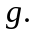 Because Using 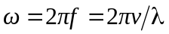 and 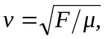 this becomes 